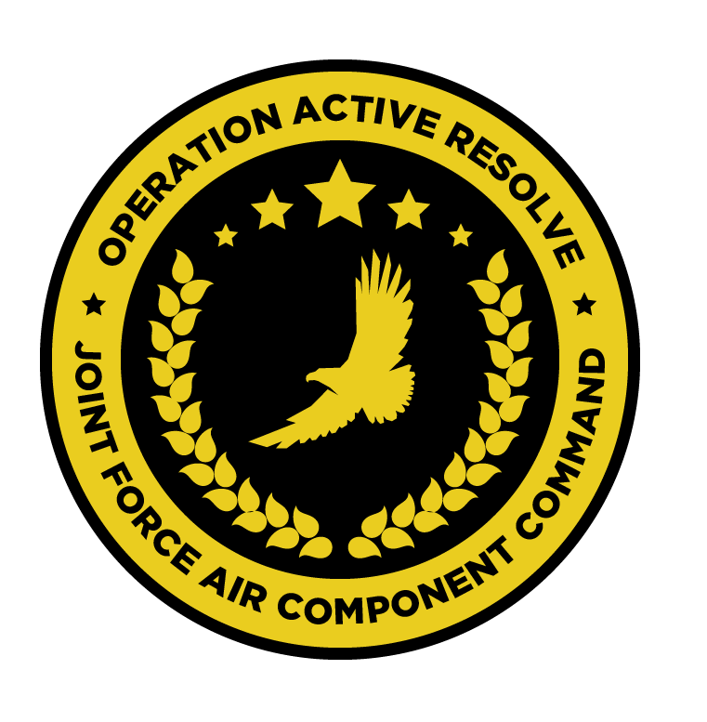

JFACC JOINT AIR OPERATIONS PLAN

OPERATION ACTIVE RESOLVE

# Situation.

See OPAR CJTF82 OPERATION ORDER.

## Adversary Forces.

See OPAR CJTF82 OPERATION ORDER and OPAR brief.

## Friendly Forces.

See OPAR CJTF82 OPERATION ORDER and OPAR brief.

# Mission.

JFACC will establish air superiority in the area of operations, and defeat Syrian offensive capability in support of CJTF-82 offensive operations to neutralize Syrian offensive capability to conduct offensives in the region.

# Air Operations

## Joint force air organization.

* 132nd Virtual Wing
  + 617th Squadron: A10C
  + 696th Squadron: KA-50
  + 259th Squadron: MI-8
  + 494th Squadron: F/A-18C
  + 108th Squadron:F-14B
  + 388th Squadron: F-16C
  + 23rd JTAC Squadron
  + 176th AWACS Squadron: E-3
* 7 WEDS: MI-8
* KC-135 MPRS Squadron
* KC-135 Squadron
* 2x Patriot Battalions

## Joint force air objectives.

1. Establish and maintain air superiority over:
   1. Turkey
   2. Israel
2. Destroy Syrian WMD capability.
3. Establish and maintain air superiority over Syria for completion of CJTF-82 objectives.
4. Degrade Syrian ground forces.
5. Execute AI campaign to :
   1. Neutralize Syrian long term offensive capability in the region.
   2. Reduce Syrian will to conduct military operations in the region

## Beddown overview.

* 132nd Virtual Wing: Split between Incirlik and Ramat David Airbase
  + 617th: 1 detachment Incirlik and one detachment at Ramat David Airbase
  + 696th: 1 detachment Incirlik and one detachment at Ramat David Airbase
  + 259th: 1 detachment Incirlik and one detachment at Ramat David Airbase
  + 388th: 1 detachment Incirlik and one detachment at Ramat David Airbase
  + 494th Squadron: Carrier
  + 108th Squadron: Carrier
* 7 WEDS (MI-8): Split between Incirlik and Ramat David Airbase
* KC-135 MPRS Squadron: Incirlik
* KC-135 Squadron: Incirlik
* E-3 Squadron: Incirlik
* Patriot BN 1: Incirlik
* Patriot BN 2: Ramat David Airbase

## Phases of joint air operations in relation to CJTF operation

### Phase 1. Shaping

In **phase 1.1** the focus of air operations will primarily be to conduct DCA operations in support of the following objectives:

* To protect friendly assets.
* To stop Syrian aggression from the air into Turkish and Israeli airspace, in order to protect own ground forces from Syrian air attacks.
* To provide support to friendly ground forces by attacking Syrian ground forces in Israel and Turkey.

Where opportunities present, this phase shall include OCA operations in order to attrit air defense and command & control capabilities within Syrian forces.

In **phase 1.2** focus will shift from DCA to OCA operations, in order to reduce Syrian ability to project power from the air into Turkey and Israel.

DCA operations will continue to protect friendly ground forces from Syrian air attacks.

The provision of support to friendly ground forces by attacking Syrian ground forces in Israel and Turkey will continue.

### Phase 2. Decisive action

In **phase 2.1** the focus of air operations will see the continuation of OCA missions to achieve air superiority in the support of friendly ground forces and the defeat of Syrian air defenses in order to set conditions for air interdiction operations.

Support will continue to be provided to friendly ground forces by attacking the Syrian ground forces, as friendly ground forces commence their attacks into Syria in this phase.

DCA operations will continue to protect friendly ground forces from Syrian air attacks.

In **phase 2.2** focus of the air operations will shift from OCA to Air Interdiction in order to destroy the long-term Syrian ability to conduct offensives in the region.

Support will continue to be provided to friendly ground forces by attacking the Syrian ground forces, as friendly ground forces continue their attacks into Syria in this phase.

DCA operations will continue to protect high value assets such as AWACS, Carriers and tankers.

### Phase 3. Stabilization

In **phase 3.1** the primary focus of air operations will be to support friendly ground forces conducting counter insurgency operations, as Syrian Air forces should be defeated and Syrian ground forces offensive capability should have been destroyed.

DCA operations will continue to protect high value assets such as AWACS, Carrier and tankers.

### Timing and duration of phases.

* Phase 1: Shaping
  + Phase 1.1: DCA + Support ground forces
    - D+1 to D+4
  + Phase 1.2: DCA+ Support ground forces + OCA
    - D+5 to D+8
* Phase 2: Decisive action
  + Phase 2.1: DCA+Support ground forces+ OCA
    - D+9 to D+11
  + Phase 2.2: DCA+Support ground forces + Air Interdiction
    - D+11 to D+25
* Phase 3: Stabilization
  + Phase 3.1: DCA+ Support ground forces
    - D+26-D+35

## Master Air Attack Plan (MAAP)

* Destroy/neutralize air defense command and control.
* Destroy nuclear, biological and chemical weapons storage and production capability.
* Make ineffective the Syrian national and military command, control and communications infrastructure.
* Destroy key electrical grids and oil storage facilities.
* Destroy POL (Petroleum, Oil, Lubricants) infrastructure.
* Reduce Syrian ability to produce military equipment.
* Deny military resupply capability.
* Reduce Syrian repair capability.
* Eliminate Syrian long-term offensive capability.
* Render the Syrian ground forces ineffective.

## Coordinating Instructions.

* Civilian air traffic is expected in and out of Beirut, Lebanon. Civilian traffic will follow published routes in Airspace Control Plan (ACP).
* Civilian air traffic is expected in and out of Haifa, Israel. Civilian traffic will follow published routes in Airspace Control Plan (ACP).
* Civilian air traffic is expected in and out of Adana, Turkey. Civilian traffic will follow published routes in Airspace Control Plan (ACP).
* All other civilian airfields in Turkey, Israel and Lebanon is closed.
* Civilian air traffic is expected in Syrian from the EAST (via corridor in Iraq into eastern Syria). No civilian air traffic is going from WEST into Syria. Civilian traffic will normally follow published routes in Airspace Control Plan (ACP).
* JFACC will on behalf of CJTF-82 provide an advisory to civilian air traffic to avoid Syria once phase 2 of the operation is underway. (JFACC responsibility).
* All JFACC units will pay attention to avoid any downing of civilian air traffic.
* All JFACC units will pay particular attention to not attack any Russian units in order to make sure Russia stays out of the conflict.

## Expected sortie availability (for planning purposes)

* A-10: 2-6
* F/A-18: 4-8
* F-16: 2-6
* F-14:2-6
* KA-50: 2-6
* MI-8:2 (259th + 7 WEDS)
* KC-135:3
* E-3:1-2

### Surge operations:

Supporting assets, such as KC-135, KC-135 MPRS and E-3 can surge their operations for one ATO day (increasing their numbers by one, but the next event will then have one aircraft less due to maintenance). Decision to conduct surge operations rests with JFACC and is ordered in the AOD if required.

# Logistics.

* C-17 and C-130s will establish regular resupply into Ramat David and Incirlick Airbases for delivery of high priority items.

# Command. Control. and Communications

## Command

* All RW operations is controlled by JFACC
* All naval air operations is controlled by JFACC

### Chain of command:

JFACC --> AOC --> AWACS --> (Mission Commander) --> Flight lead

Mission commander only relevant for COMAO/Package operations tasked as such on the ATO.

* AOC breaks down guidance and priority from JFACC into an executable Air Tasking Order (ATO).
* During execution of the ATO, AWACS is delegated authority from JFACC and AOC to execute the mission in accordance with (IAW) JAOP, AOD and ATO
* Daily a AOD will be published from JFACC that provides updated guidance, priorities and allocation. AOD D+1 will give guidance for ATO D+1.
* Daily a ATO will be published, based on the AOD.
* (Daily= Per event. 1 event/1 day= 14 day cycle minimum)

## Communications

Frequencies and callsigns IAW OPAR SPINS (available on OPAR briefing page).

**CombatFlite files:**

* Airspace Control Plan (ACP) : All nav-points, CP/IP, tanker tracks, , AWACS tracks, FAOR, No-fly zone, Killboxes etc
  + Available on website. Updated by AOC.
* Target overlay
  + Available on website. Updated by VIS/JFACC.
* Intelligence overlay
  + Available on website. Updated by VIS.